Urology Resource Centre: Trimix (Triple Mix) Instructions:

Where can you get Trimix: You must have a prescription for Trimix and it is only available at compounding pharmacies where they mix the medications at the pharmacy. Please phone before going to the pharmacy to ensure that Trimix is available and to give them time to prepare it. Trimix is a clear liquid and is usually placed into two vials (2 ml/vial), however it is suggested that the first time you try Trimix that you ask the pharmacy for only one vial. This will allow you to try Trimix without spending as much money. A list of compounding pharmacies close to Burlington is provided below.
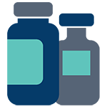
Compounding Pharmacies close to Burlington:
- Marchese Pharmacy, 316 James Street North, Hamilton, ON LBL 1H2 P:905-528-4214
- Concession Medical Pharmacy, 444 Concession St, Unit 101, Hamilton, ON, L9A 1C2 P: 905-387-7125
- ORIGINS Pharmacy & Compounding Lab North Oakville Medical Building 3075 Hospital Gate, Suite 108 Oakville, ON L6M 1M1 P: 905-847-9696

Needed Supplies: Your prescription will also include information about supplies needed besides the vial of Trimix. You also need to have alcohol swabs, a sharps container and syringes.
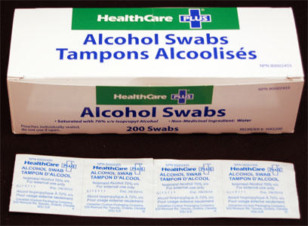
A box of alcohol swabs
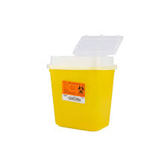
A sharps container. When full of used needles, return container to the pharmacy for disposal

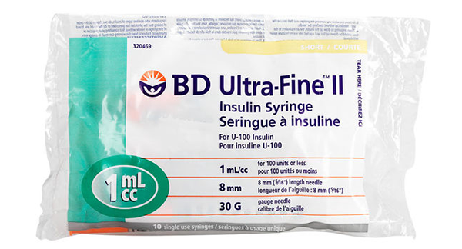
A bag of 10 syringes. Use only each syringe once then place in sharps container. Usually use 1ml syringe, 30 Gauge width and 8mm or 5/16th inch needle length

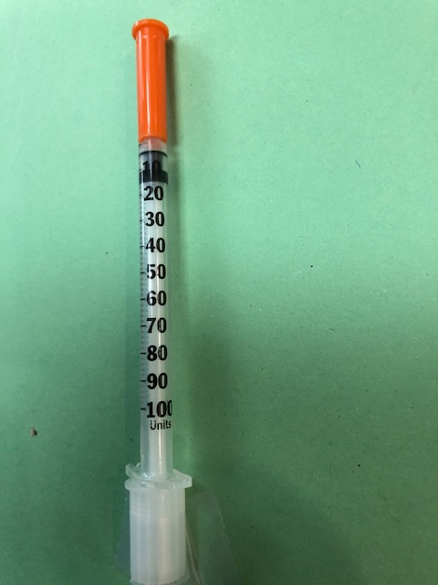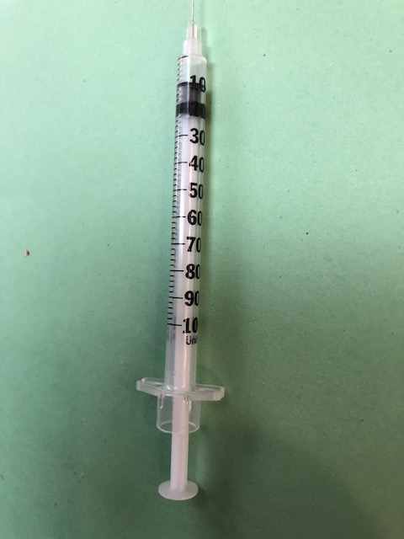
Syringe with orange cap and white cap off. Showing dose of 0.1ml or 10 units.
Syringe with orange cap over needle and white cap over the plunger

The syringe: Your Trimix prescription has the information for the correct syringes to use. They are 1ml insulin syringes with a very fine needle. The marked numbers on the side are actually in “units” from 10 to 100. Ten units = 0.1 ml.
Dosage of Trimix: It is very important for you to slowly determine the correct dosage for yourself that will provide a satisfactory erection that does not last longer than 1 hour. One risk of using injection therapy is a prolonged erection (priapism) that lasts longer than 4 hours. If this prolonged erection happens you must go to the emergency department of the nearest hospital for treatment. For an erection lasting more than 1-2 hours try walking up and down the stairs for a few minutes. There has been recent research showing that walking up and down the stairs may help reduce the erection.
The dosage of Trimix needed to provide an erection lasting 1 hour or less is different for every man. The maximum dosage of regular strength Trimix is 0.5ml (or 50 units as marked on the syringe).
The following “titration” instructions are important to follow:
- 1st injection: try 0.1ml (or 10 units as marked on the side of the syringe). If this is not successful, do not give yourself a second injection. Wait a minimum of 24 hours to try again.
- 2nd injection: try 0.2ml (or 20 units as marked on the side of the syringe). If this is not successful, do not give yourself a second injection. Wait a minimum of 24 hours to try again.
- 3rd injection: try 0.3ml (or 30 units as marked on the side of the syringe). If this is not successful, do not give yourself a second injection. Wait a minimum of 24 hours to try again.
- 4th injection: try 0.4ml (or 40 units as marked on the side of the syringe). If this is not successful, do not give yourself a second injection. Wait a minimum of 24 hours to try again.
- 5th injection: try 0.5ml (maximum dose of regular strength trimix) or 50 units as marked on the side of the syringe. If this maximum dose is not successful, please get in touch with the nurse or your urologist to prescribe double strength trimix.
How often Trimix can be used: It is recommended that Trimix can be used up to 3 times/week with 24-48 hours in between injections. Please follow the Origins Pharmacy instructions for injection of Trimix (used with permission of Origins Pharmacy). Also read the Urology Resource Centre’s document on Precautions with Injection Therapy.

