What is a penile vacuum pump?
A penis pump is one of a few treatment options for the inability to get or maintain an erection sufficient for sex (erectile dysfunction). The penis pump consists of a plastic tube that fits over the penis, a hand or battery-powered pump attached to the tube, and a band (constriction ring) that fits around the base of the penis once it is erect. The tube and pump are used to create a vacuum helping the blood flow into the penis to create an erection. The band/constriction ring maintains the erection by keeping blood inside the penis. You might want to trim or shave any pubic hair near the base of the penis so that it does not get caught in the ring.
The use of lubricating jelly around the opening of the tube helps to create a good seal against the body enabling the vacuum. Lubricating jelly is also helpful around the base of the penis to slide the constriction ring to slide on and off.
Intercourse can be attempted with the constriction ring in place to help maintain the erection. The ring can be left on safely for up to 30 minutes.

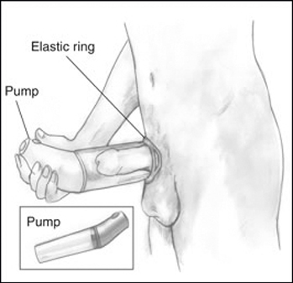
Image of a Penis Pump and Elastic or Constriction ring
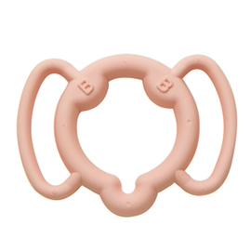
Image of one type of constriction ring
How well do penile vacuum pumps work?
Studies suggest that about 50-80% of men are able to get an erection satisfactory for sexual intercourse. Long term satisfaction or happiness with the device may be less than that.
Risks of penile vacuum pumps:
The risk of side effects are low, and they are usually minor. Possible problems may include:
- Bruising
- Pain or discomfort
- Numbness or loss of sensitivity
- A sensation that the penis is cold and bluish coloured skin
- Pinching scrotal tissue in the device
Talk to your urologist if you are taking blood thinning medication e.g., warfarin (coumadin) and clopidogrel (Plavix), as you are at an increased risk of bleeding. Also do not use a penile pump if you have sickle cell anemia or another blood disorder.
What to think about:
Be sure to discuss using a penile vacuum pump with your partner. It is important that you both have realistic expectations of what the device can do. The vacuum device gives you an erection that is sufficient for intercourse but it is not the same as a normal erection.
The device can be difficult to learn to use and you may need about four tries to learn to use it successfully. Some men find the constriction ring distracting or irritating during sex.
Choosing a Penile Vacuum Pump:
You can purchase a penile pump in a sex shop or on-line. You are advised to speak to your urologist or nurse before purchasing. Choose a model with a “quick release” valve which helps in decompressing the erection. Also choose a model that has constriction rings/bands. If your penile girth is larger than many men, then speak to your nurse about other options as the standard model may cause some pain. Some insurance companies cover the cost of a penile vacuum pump so speak with the nurse about obtaining a prescription signed by your urologist.

