Vacuum Pump Therapy for Peyronie’s Disease
Urology Resource Centre/Burlington Urology

Peyronie’s (pronounced pay-row-NEEZ) disease is a condition caused by the accumulation of dense, scar-like tissue in the penis also called “plaques”. No one knows why plaques develop although sometimes it seems to be related to trauma to the penis. The problem is that the plaques can cause pain and curvature in an erect penis. Erections occur when blood rushes into— and then is temporarily trapped in—the corpora cavernosa, the pair of tube-like structures that run the length of the penis. The plaques occur in tissue that surrounds the corpora cavernosa. When a man has Peyronie’s, the plaques may impinge on the distended corpora cavernosa like a crimp in a hose, which can cause a curvature in the penis that may make intercourse difficult. If they hit a nerve, they can cause pain. Men of any age can be affected.
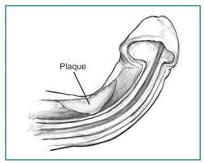
Image of a Peyronie’s plaque
Vacuum pump therapy is a conservative way to treat Peyronie’s. One study has shown that regular use of the vacuum pump stabilized or improved penile curvature in 90% of patients. A penile vacuum pump is a hollow tube/cylinder that fits over the penis. A vacuum pump is used to remove air from the tube creating a vacuum that pulls blood into the penis producing an erection. Vacuum pump therapy mechanically straightens the penis and with regular use it stretches the penis and helps to break down the plaque.

The following are “tips” on how to use the vacuum pump to treat Peyronie’s Disease:
- You get what you pay for. Very inexpensive vacuum pumps may not work very well.
- Try to claim the vacuum pump on your insurance plan if you can (not all insurance plans cover the cost however). If you need a note from your urologist please contact Laura Robbs RN at burlingtonurology@gmail.com
- Read the instruction manual very carefully before use.
- Be patient as you start as it may take some time to get used to producing an erection with a vacuum pump. Use a gradual increase in pressure and a gradual increase in duration of the vacuum forces.
- Do not use the pump more often than twice a day. You could cause bruising or skin injury.
- The key to producing a vacuum is a seal against your skin. Use water soluble lubricant around the pump opening/cylinder where it fits around your penis to help create this seal. If you are very hairy you might want to trim the hair as it can prevent a good seal around the penis.
- Try to use the pump 10 minutes twice daily to stretch the penis. Slowly apply the vacuum until the penis is erect and maintain the erection for 3 minutes. Release the vacuum to allow erection to subside and repeat twice more (for a total of 10 minutes). Repeat this procedure once more during that 24-hour period.
- Use the pump for a 3-month period and follow up with your urologist.
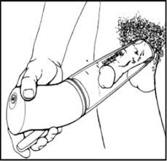
Image of a penile pump that is controlled by the user’s hand

Choosing a Penile Vacuum Pump:
You can purchase a penile pump in a sex shop or on-line. You are advised to speak to your urologist or nurse before purchasing. Choose a model with a “quick release” valve which helps in decompressing the erection. Also choose a model that has constriction rings/bands if you have issues with erectile dysfunction. If your penile girth is larger than many men, then speak to your nurse about other options as the standard model may cause some pain. Some insurance companies cover the cost of a penile vacuum pump so speak with the nurse about obtaining a prescription signed by your urologist.

